1. Voltage Switch
2. Latch
3. D-Sub Connectors
4. Ethernet Cable
5. Power Cable
6. D-Sub to CPC Cable

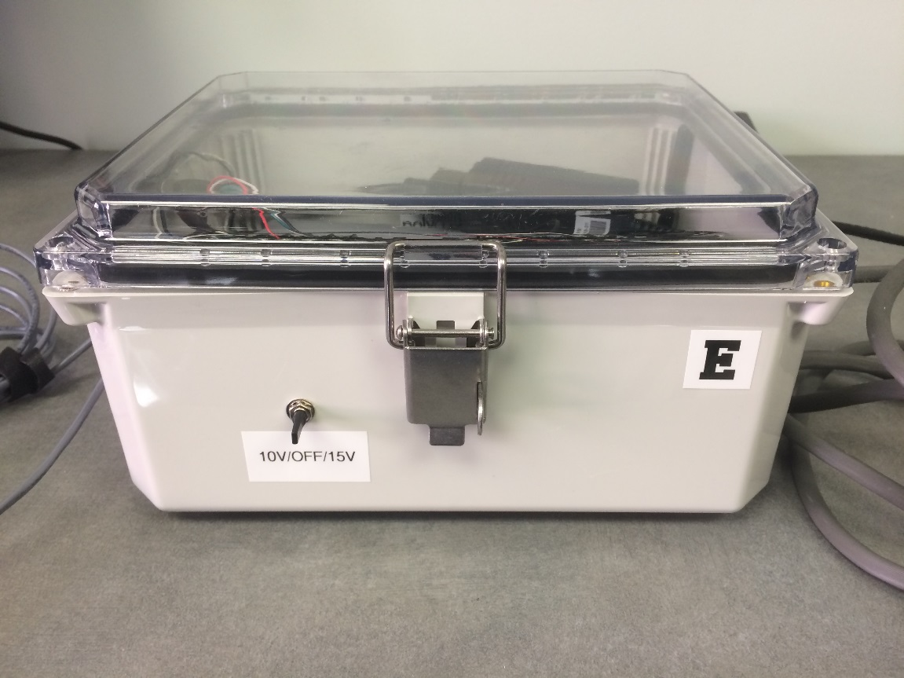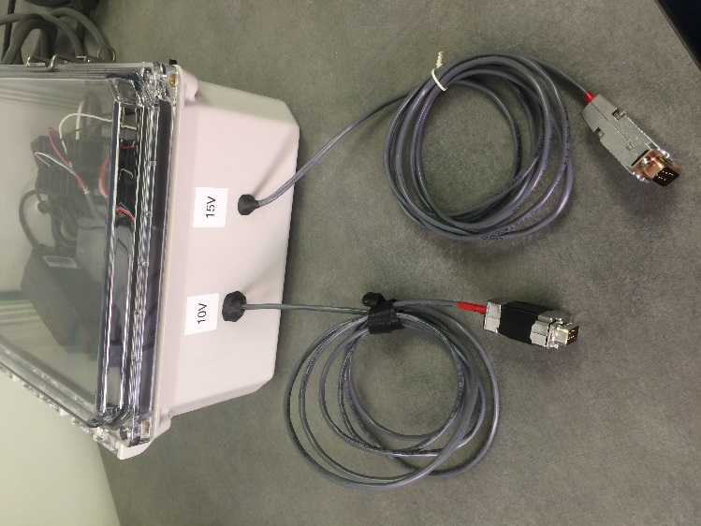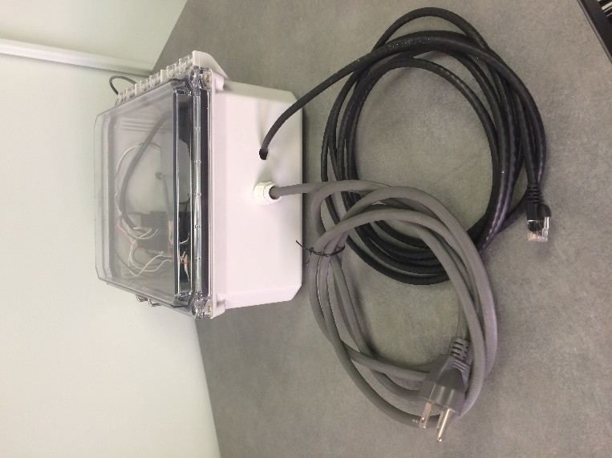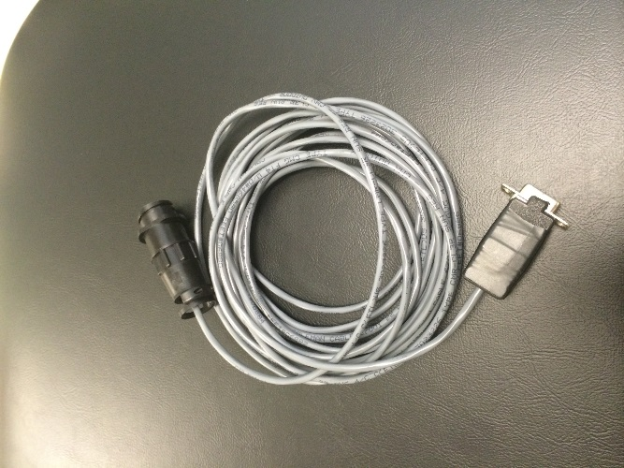

**1**

**3**

**2**

**4**

**5**

**6**

1. Plug the power cable (4) into the wall.
2. Connect the force box to the transducer (see table for appropriate voltage and connector).
3. If using Ethernet, plug the cable (4) into the NI chassis and the computer. The force box can be opened with the latch (2). If using Wi-Fi, this will be covered later.
4. Flip the voltage switch (1) to the appropriate voltage (same as the d-sub cable used).
5. Turn on the computer and follow the force system instructions.

|  |  |  |  |
| --- | --- | --- | --- |
| Transducer | Exercise Device | Excitation Voltage | Connector |
|  | Force Chair Quad Exercise Device | 10V | D-Sub  Note: This is the only transducer that connects directly to the force box |
|  | MR Quad Exercise Device | 10V | CPC |
|  | Hand Grip | 10V | CPC |
|  | Foot Exercise Device | 15V  Note: Can operate with 10V | CPC |